FIGURE 2. The overview operation of the SHA-256 algorithm

FIGURE 1. The generation of a SHA-256 hash value for a long message

Figure: 4.1  
File size v/s Encryption & Decryption Time for .txt files for  
Proposed Algorithm

Figure 13. Comparison of computational cost of different ECC curves. (a) Computational cost  
(sec). (b) Computational cost (KB)

Figure 3. Comparative encryption time of AES-128 and  
AES-256

Figure 4. Comparative decryption time of AES-128 and  
AES-256

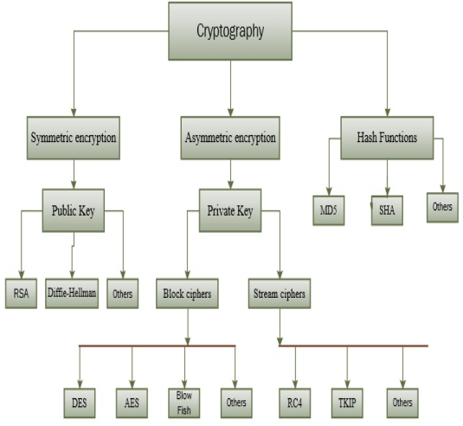

Figure 1 Types of Cryptography